**GIT Commands**

* **git –version**



Means successfully installed

* **configure – to know who is checking in and making changes**

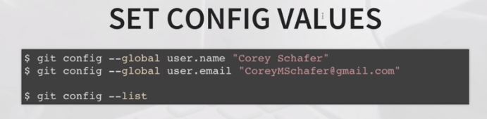

* **When you need help. That works with all the other commands too**

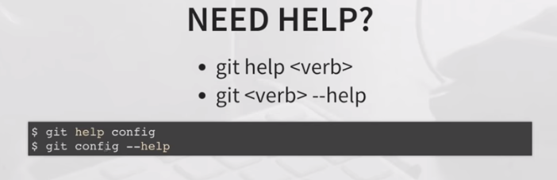

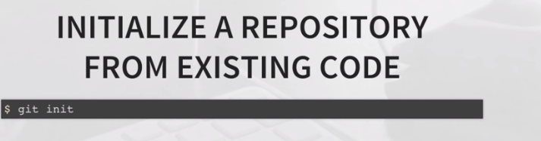

Creates empty repository in local-Repo

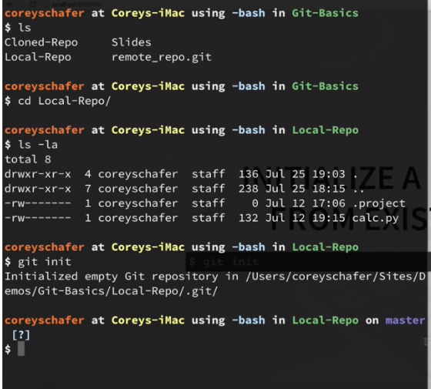

.git directory contains everything in our repository.

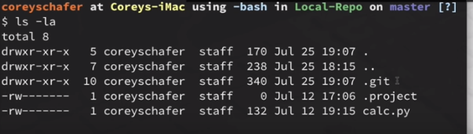

To stop tracking our project with git we can stop by removing

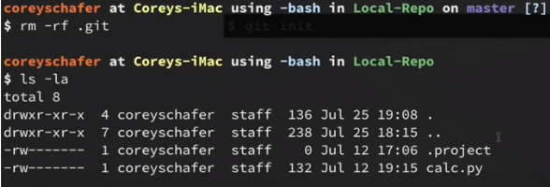

Shows status

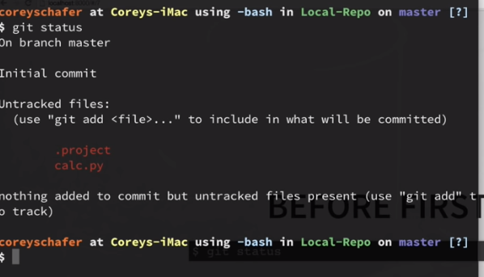

Currently we are working on working directory.

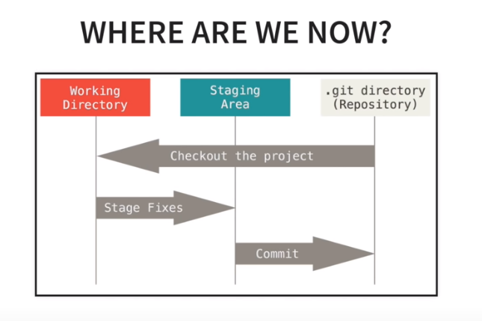

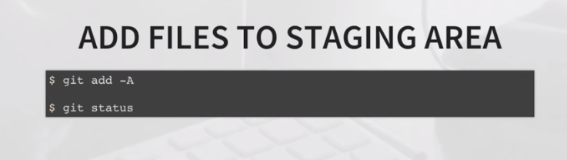

.gitignore is added to staging are.

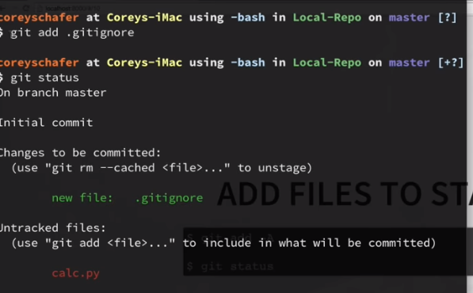

With git add –A all the files are added to staging area.

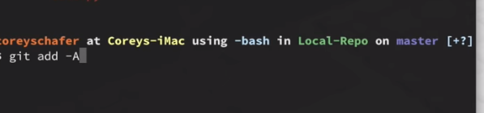

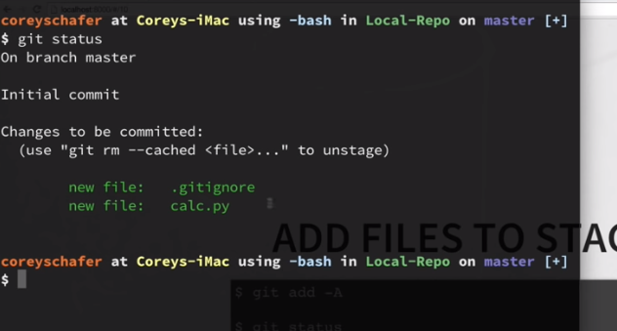

To remove particular file from STAGING AREA

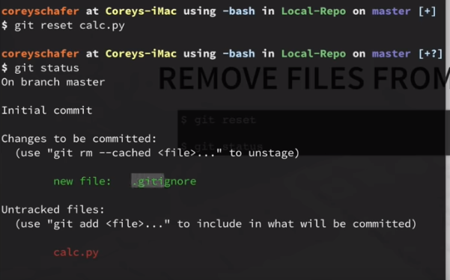

To remove all the files from STAGING AREA

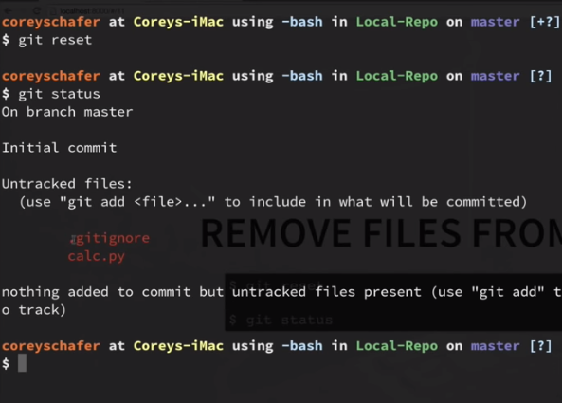

TO commit a file

First add then commint

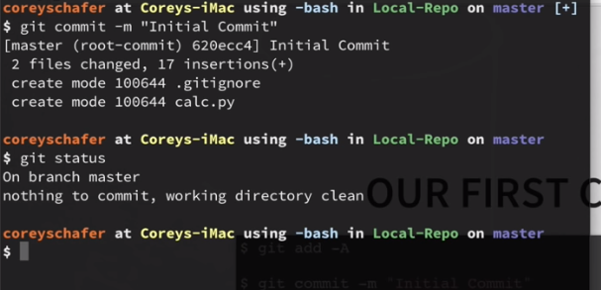

Git commit id

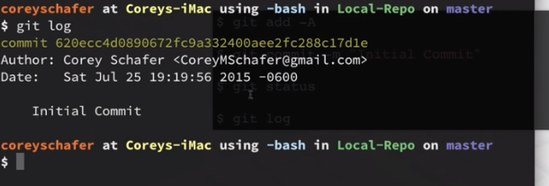

In the work place if you want to work on existing project.

Company has a remote repository and if you want to clone a remote repo.

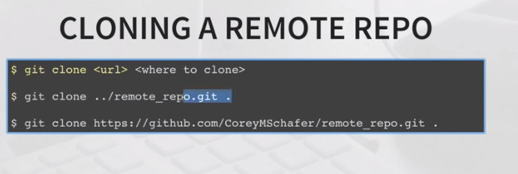

git clone <url link><address where you want to clone>

//<url link> copy the remote repo link which you have to clone

// he gave . because he wants that to be cloned rite their

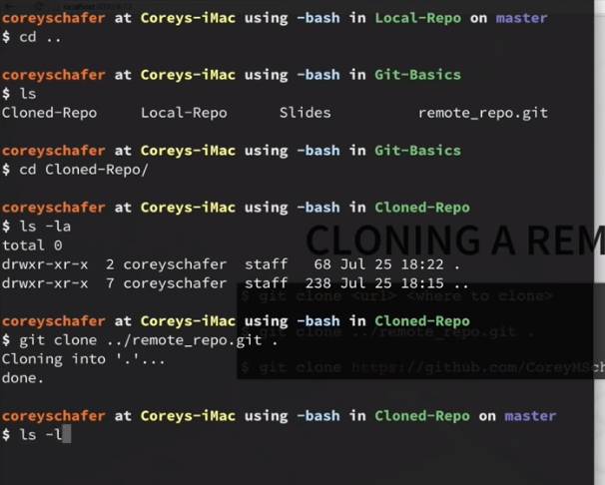

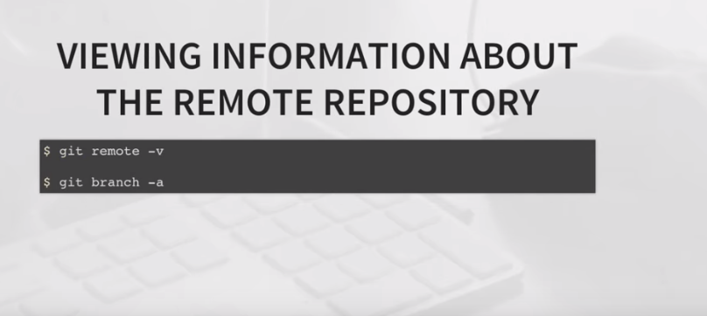

Info where the local repository is

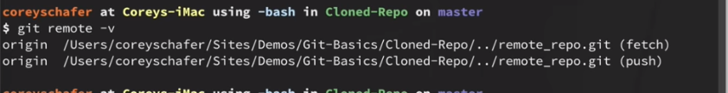

List of all the branches not only locally but also remote branches.

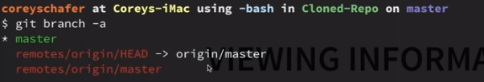

To push the changes to remote repo

If we made any changes in our code then first we have to commit the changes locally

Git diff show me the changes I have made.

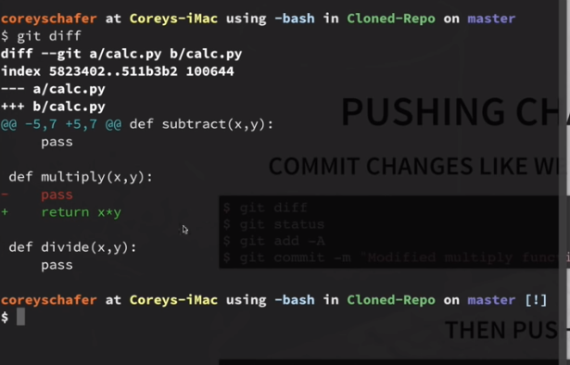

//-pass I removed

//return x*y I added

calc.py file was modified

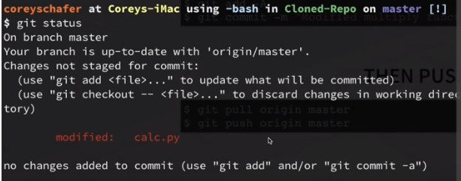

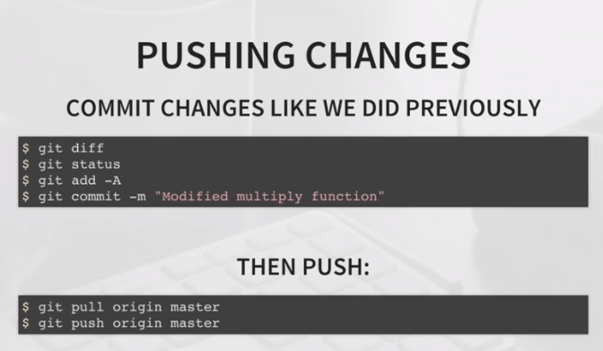

Add all the changes to staging area

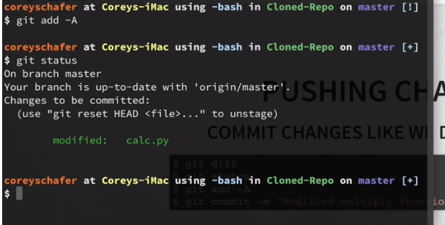

Commited file locally

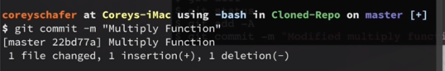

To push changes to remote, for that first we need to pull

As many people are working they must have made changes since the last time we pulled.

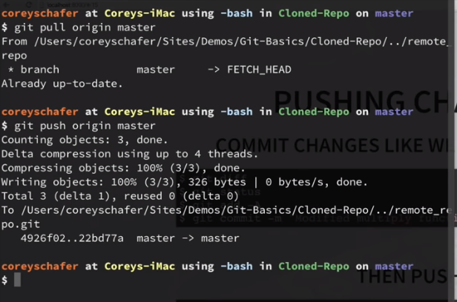

Origin – name of remote repo

Master – which branch we have to push

**Working on BRANCH**

git branch <branch name>

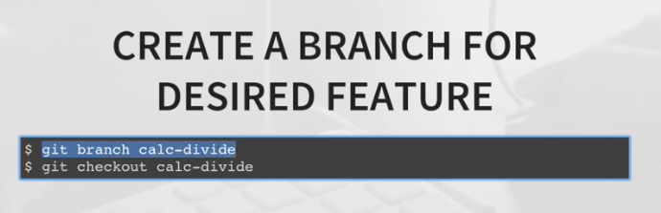

Git branch calc-divide //created new branch

//*master we are currently working on master

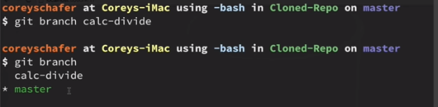

If I want to work on calc-divide branch then we have checkout

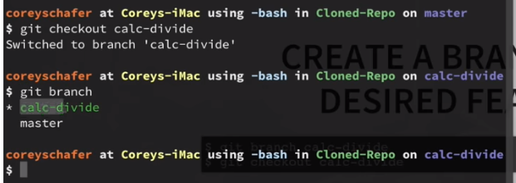

Then add, commit

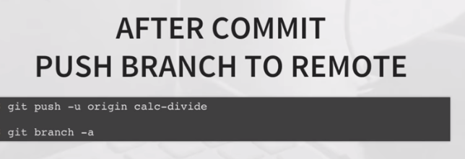

git push –u origin master

-u //we wanna associate local calc-divide to remote calc-divide

origin – name of the remote repo

calc-divide – branch we wanna push

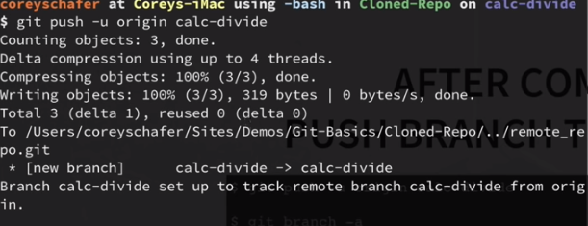

List of branches

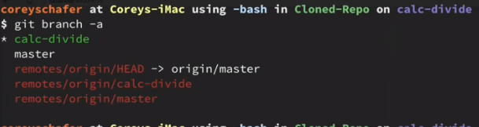

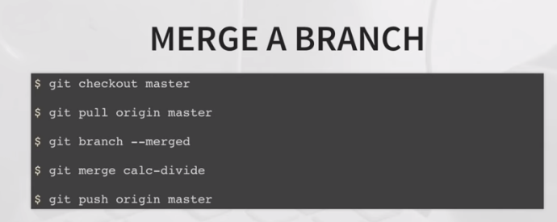

Checkout local master branch

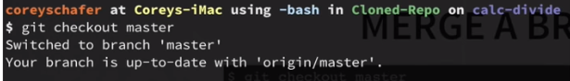

Pull in case anybody made any changes before commiting

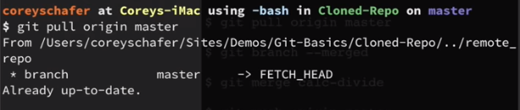

Branches that we have merged so far. Calc-devide don’t show up because we didn’t merge any.

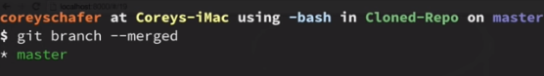

Merge with master branch

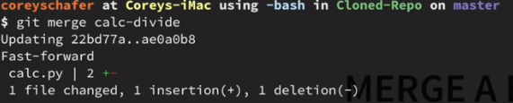

Push those changes to master

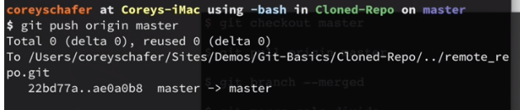

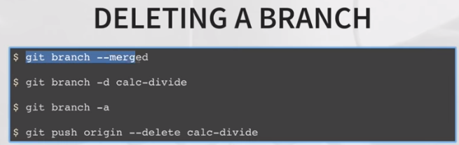

We merged calc-divide into master.

We no longer need calc-divide so delete it.

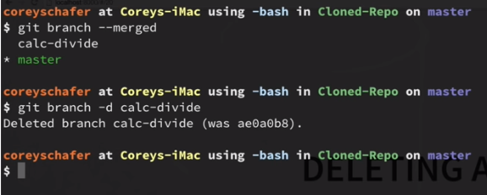

Calc-divide got deleted locally. We can see in remote repository.

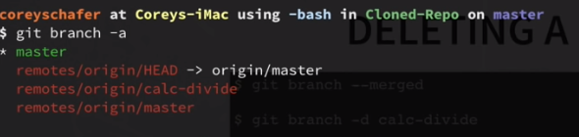

To delete from remote repository.

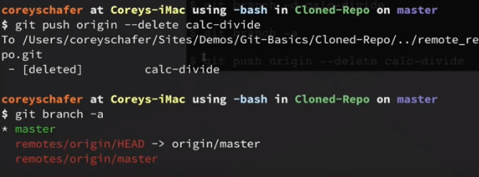

**STEP BY STEP PROCESS**

